**Step 1: Edit below Signature table with your credentials (to edit please follow step 2,3,4 & 5)**

**Signature Table: - You can edit this table here or copy (to copy please follow page no 6) this table and edit in signature section in your outlook mail.**

|  |  |  |  |  |  |  |  |  |
| --- | --- | --- | --- | --- | --- | --- | --- | --- |
| **Arunesh Dwivedi / Associate - Operations**  [cid:image001.png@01D8865A.5031A8C0](https://www.linkedin.com/in/arunesh-dwivedi-8674191ba/) | | | | | | | cid:image005.png@01D88661.29438470 | |
| **+91-993-638-0015**  [arunesh.dwivedi@effectualservices.in](mailto:arunesh.dwivedi@effectualservices.com)  [www.effectualservices.com](http://www.effectualservices.com) | | | | | | |
|  | **200+**  **Techno-Legal Professionals** | cid:image009.jpg@01D8865A.5031A8C0 | **25,000+**  **Projects Completed** |  | **5000+**  **Clients Worldwide** | cid:image012.jpg@01D8865A.5031A8C0 | | **100+**  **Customer Countries** |
| **SAN FRANCISCO & NEW YORK (U.S.A)  | LONDON & STUTTGART (EUROPE)  |  NOIDA & MOHALI (INDIA)  |  SINGAPORE** | | | | | | | | |
| Please consider the environment before printing.  The information transmitted by this email is intended only for the person or entity to which it is addressed. This email may contain proprietary, business-confidential, and/or privileged material. If you are not the intended recipient of this message, be aware that any use, review, retransmission, distribution, reproduction or any action taken in reliance upon this message is strictly prohibited. If you received this in error, please contact the sender and delete the material from all computers. | | | | | | | | |

**Step 2: Change Employee Name & Designation**

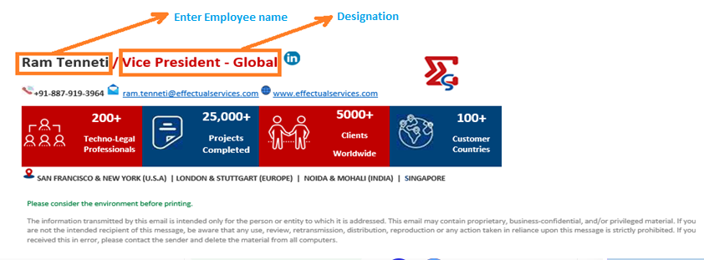

**Step 3: Edit LinkedIn hyperlink**

* **Right click on LinkedIn icon**
* **Click on Edit hyperlink**
* **Add LinkedIn profile link in address section as shown in below fig.**

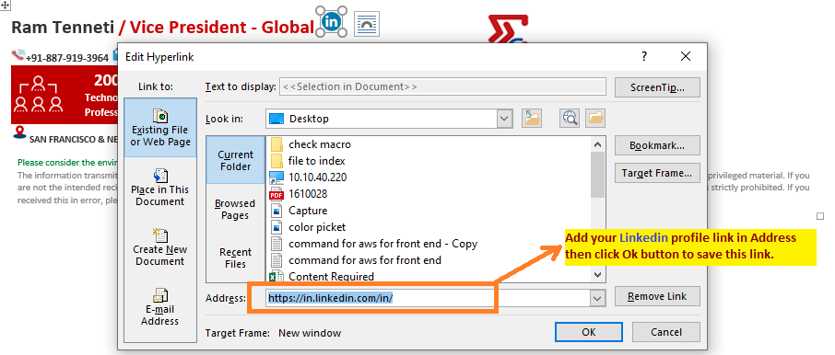

**Step 4: Edit your Contact no. and Official E-mail id**

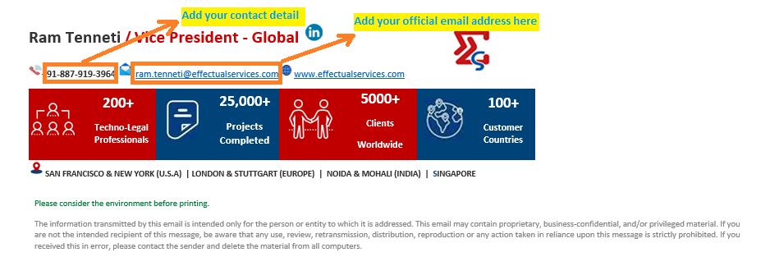

**Step 5: Add hyperlink to your official email id**

**Note:- Please don’t enter space bar to make hyperlink it will disturb the whole table so make hyperlink as per below steps.**

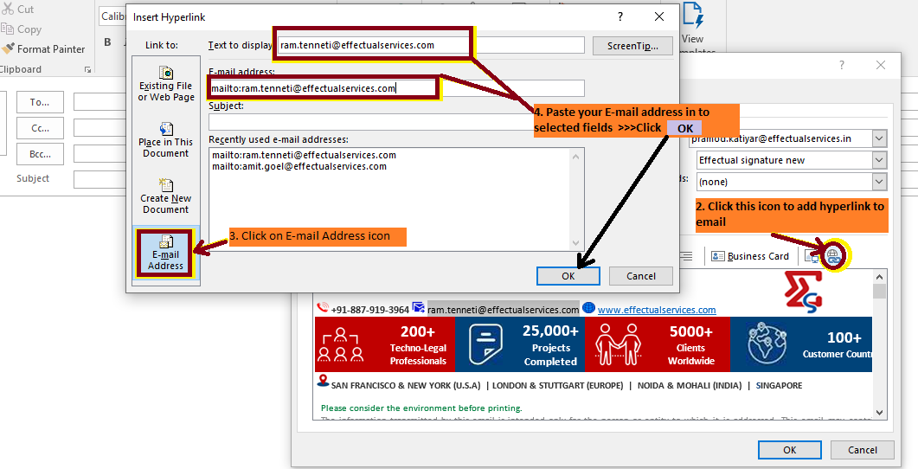

**Follow steps to add Signature in Outlook mail**

* **Copy the signature table after editing to with your own signature details.**

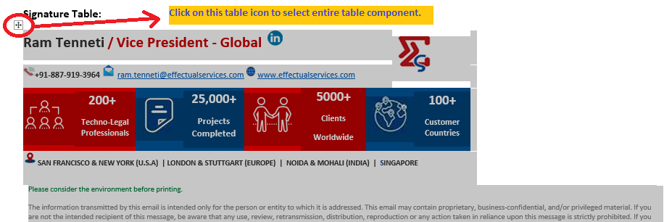

* **Outlook Home Tab>New E-mail>Message>Signatures…>New >Type a name of this Signature>OK>Edit Signature>Paste> OK**

**-: To add this signature default please enable these options: -**

